73.05.22t
To James Casey
I73/9286, unit 750, VPRS 44/P inward registered and unregistered correspondence, VA 538 Department of Crown Lands and Survey, Public Record Office, Victoria.

MELBOURNE BOTANIC GARDEN.
APPLICATION FOR SUPPLY.

Revd Thomas J. Egan
of St Patrick's Church Wangaratta
requests that he may be supplied with the following
from the Melbourne Botanic Garden for

LIST.
Space for about 150 plants
X 50 trees
X 100 miscell shrubs
Recommended already the Minister, as far as available. 5/5/73

9/4 1873 Signature of Applicant Thomas J. Egan
__________________________________________________________________

The items marked (X) can be supplied.
Melbourne Botanic Garden, 22 May 1873. Ferd. von Mueller Director.
__________________________________________________________________
Received from the Gardens the above items, as marked approved.

187
__________________________________________________________________
Notice. — No plants, cuttings, or seeds will be issued from these Gardens unless in exchange, or for public institutions or benevolent purposes.

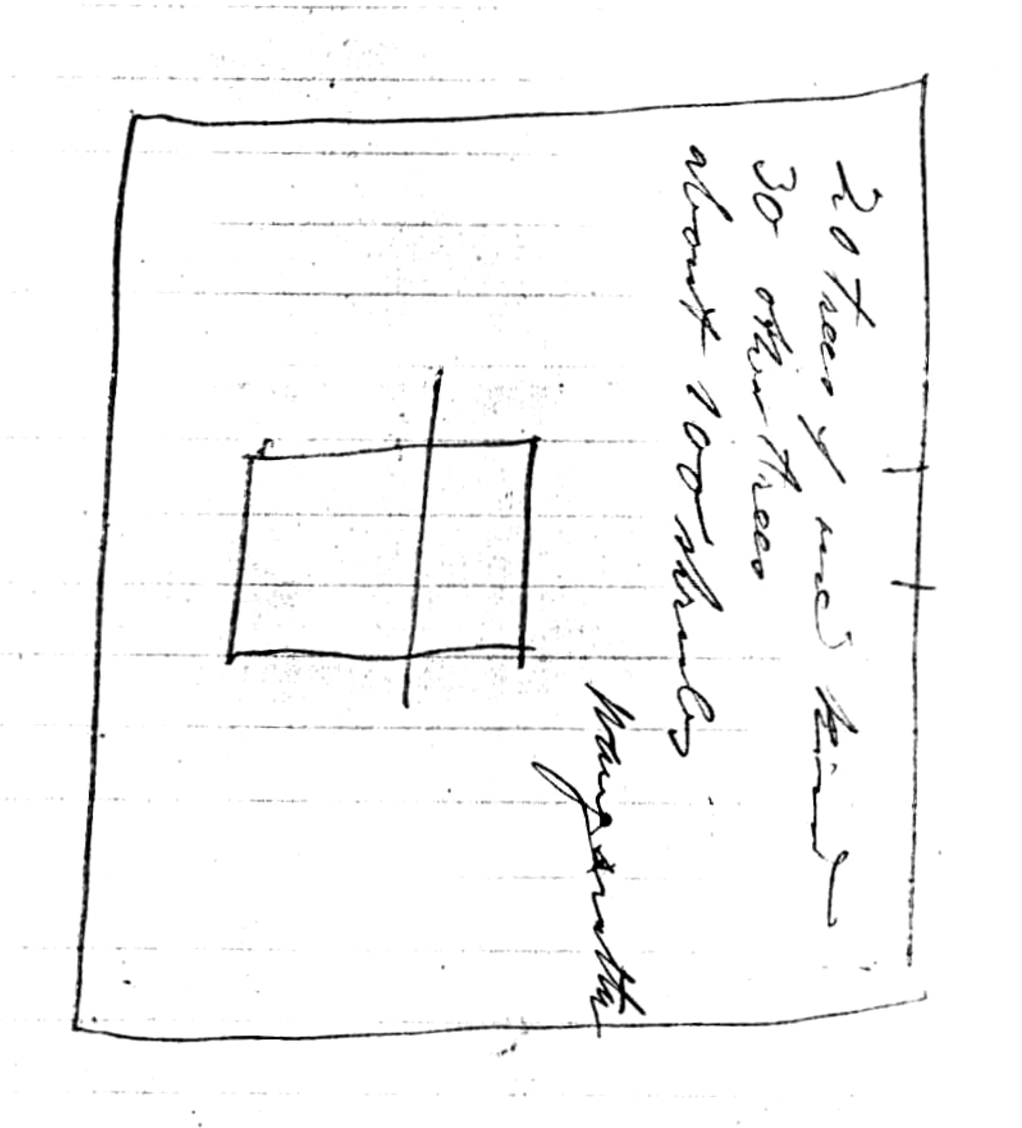
t

MS is accompanied by a sketch outline of the church grounds and a note, written in pencil by Egan, requesting: '20 trees of one kind | 30 other trees | about 100 shrubs | Wangaratta'. 73-05-22t_image01.jpg
Vic.
for approval, to the Honorable deleted. M had submitted Egan's application with M to J. Casey, 19 May 1873.

